Dashboard Design
Date | 19 september 2026
Team ID | MCA
Project Name | Smartphone Usage, Digital Addiction & Well-Being Analytics
Maximum Marks | 5 Marks

Creating an effective dashboard involves thoughtful design to ensure that the presented information is clear, relevant, and easily understandable for the intended audience. Here are some key principles and best practices for dashboard design

Activity 1: Interactive and visually appealing dashboards
Creating interactive and visually appealing dashboards involves a combination of thoughtful design, effective use of visual elements, and the incorporation of interactive features. Here are some tips to help you design dashboards that are both visually appealing and engaging for users so take care of below points:
- Clear and Intuitive Layout
- Use Appropriate Visualizations
- Colour and Theming
- Interactive Filters and Slicers
- Drill-Down Capabilities
- Responsive Design
- Custom Visuals and Icons
- Use of Infographics

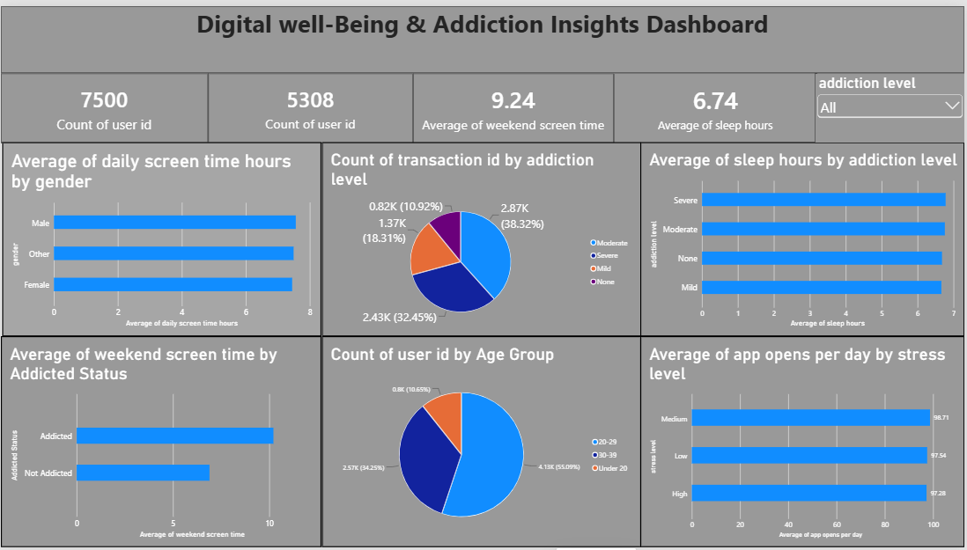

Sample:
Here are five potential outcomes from the dashboard image provided:
- Total Daily Screen Time Tracked: The dashboard monitors device usage across the cohort, identifying average daily screen time to pinpoint baseline habits and over-reliance.
- Digital Addiction Risk Categorization: Users are segmented into clear risk profiles (e.g., Low, Moderate, High) based on standardized psychological behavioral markers.
- App-Category Usage Distribution: A clean breakdowns visualizer shows how time is divided among social media, productivity, entertainment, and gaming apps to reveal primary triggers of digital distraction.
- Well-Being Index Variations: Scatter plots and tracking charts reveal the distinct correlation between high nighttime screen hours and decreasing subjective user well-being scores.

- Interactive Demographic Breakdown: Dynamic filters allow viewers to isolate addiction trends based on age brackets, occupation, and gender to pinpoint targeted demographics needing digital detox interventions.

